CURRICULUM VITAE

Dear Sir,

I intend to apply for job your company for the position DECK OFFICER and i am already to be planned on board with route of voyage determined by the company, my date are as follow :
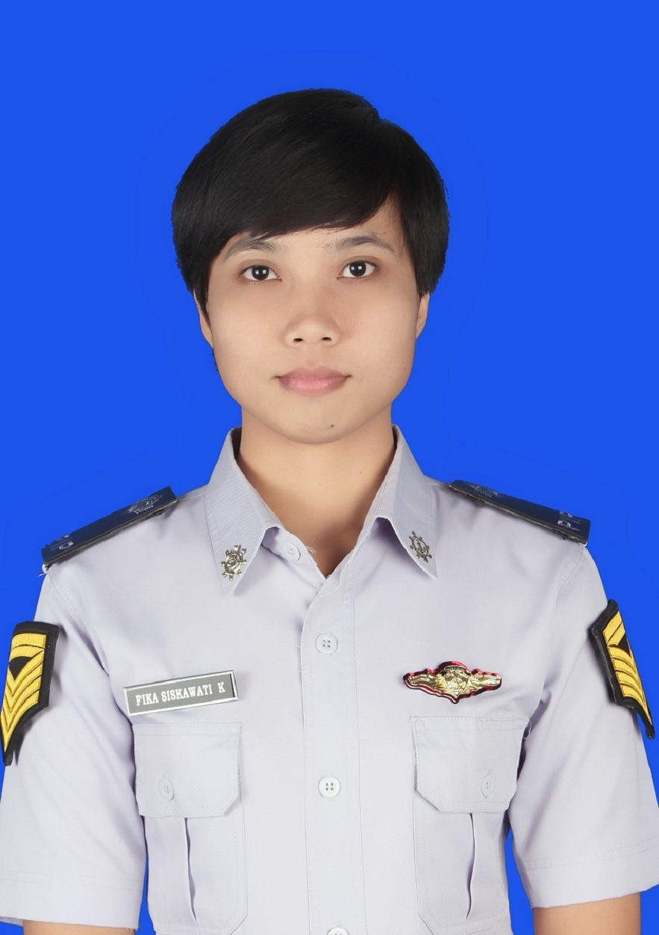
- PERSONAL IDENTITY

Name : FIKA SISKAWATI K
Register no. / departement : 12.31.071 / deck
Place/Date of Birth : Sengkang, 11 Oktober 1992
Nationality : Indonesia
Age / marital status : 24 years / single
Gender : Female
Religion : Moeslem
Address : Jl. Tentara Pelajar No. 173 Makassar
Mobile Phone / e-mail : 082343959433 / fikasiskawati@gmail.com
Institution Name & Addres : Politeknik Ilmu Pelayaran Makassar
Jalan Tentara Pelajar No. 173

- PERSONAL DOCUMENT

No | Detail Of Document | Serial Number | Date Of Issue | Expired Of Date | Place Of Issue
1 | Passport | A 7993372 | 06 Juni 2014 | 06 Juni 2019 | Makassar
2 | Seaman Book | C 077881 | 05 August 2014 | 04 August 2017 | Makassar
- CERTIFICATE OF PROFICIENCY

No | Name Of Certificate | Number Of Certificate | Date Of Issue | Place Of Issue
1 | Basic Safety Training |  | 22 February 2013 | Makassar
2 | Medical First Aid | 6202189998070413 | 27 February 2013 | Makassar
3 | Advanced Fire Fighting | 6202189998060413 | 29 July 2013 | Makassar
4 | Arpa Simulator | 6202189998020414 | 18 January 2014 | Makassar
5 | Medical Care On Board Ship | 6202189998080414 | 22 January 2014 | Makassar
6 | Tanker Familiarization | 6202189998090413 | 24 July 2013 | Makassar
7 | Radar Simulator | 6202189998030413 | 22 Agustus 2013 | Makassar
8 | Security Awereness Training | 6202189998310414 | 23 July 2014 | Makassar
9 | Ship Security Officer | 6202189998240414 | 21 Agustus 2014 | Makassar
10 | Seafarers With Designated Security Duties | 6202189998320414 | 21 July 2014 | Makassar
11 | International Safety Management Code | 020/ISM CODE/PIP MKS-04 | 21 Juni 2016 | Makassar

Consider my application and would be please to call me anytime and convenient to you

Yours Faithfully,

FIKA SISKAWATI K

